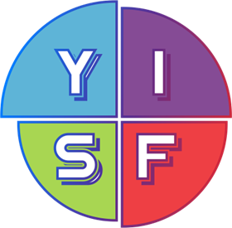 | PROGRAMME  of the Yakutia International Science Fair 2026  (3rd International Science Games)  for the participants  July 2-4, 2026  Time Zone GMT +9 (Yakutsk City)  Format: hybrid (blended)
Time  GMT+9 | Event | VENUE
July 2 (Tuesday)
11:00-12:00 | Registration and accreditation of in-person attendees | North-Eastern Federal University in Yakutsk (NEFU)
15:00-16:00 | The grand opening of the of the  3rd International Science Games  Format: Hybrid (blended) | Cultural center the North-Eastern Federal University  (for in-person participants)  Connection to the ZOOM conference:  (for online participants)
July 3 (Friday)
15:00-19:00 | Oral presentations.  Format: Hybrid (blended) | North-Eastern Federal University  Rooms #263  (for in-person participants)  Connection to the ZOOM conference:  (for online participants)
17.00-18.00 | Networking break | North-Eastern Federal University  (for in-person participants)  Rooms #263
15:00-19:00 | Online poster competition  “Public choice” | Online voting link: https://ysf.lensky-kray.ru/en
July 4 (Saturday)
16:00-17:00 | Science popularization lecture  Format: online | Connection to the ZOOM conference:
19:00-20:00 | Grand closing ceremony of the Conference. Format: online. | Connection to the ZOOM conference:
Note:
- The cultural program for in-person participants and their mentors will be held according to the program of the 3rd International Science Games.
- The business program for educators will be held according to the program of the event «Educational Salon» of the 3rd International Science Games.

